
BAHRIA UNIVERSITY (KARACHI CAMPUS)

Assignment 2

Formal methods in software engineering

Class: BSE 5A/B (Morning )
Course Instructor: (Prof.Engr Faiz ul haque Zeya) Time Allowed: (23/12/2022)
Date: 13/12/2022 Max Marks: 5 marks
Student’s Name: __M Muaz Shahzad_ Reg. No: 02-131202-081

CLO 2 5 mark

Q1. Draw Z description(init,operating and state schemas) of learning management system at least 5 modules. (total 15 schemas 3*5).

1st Module
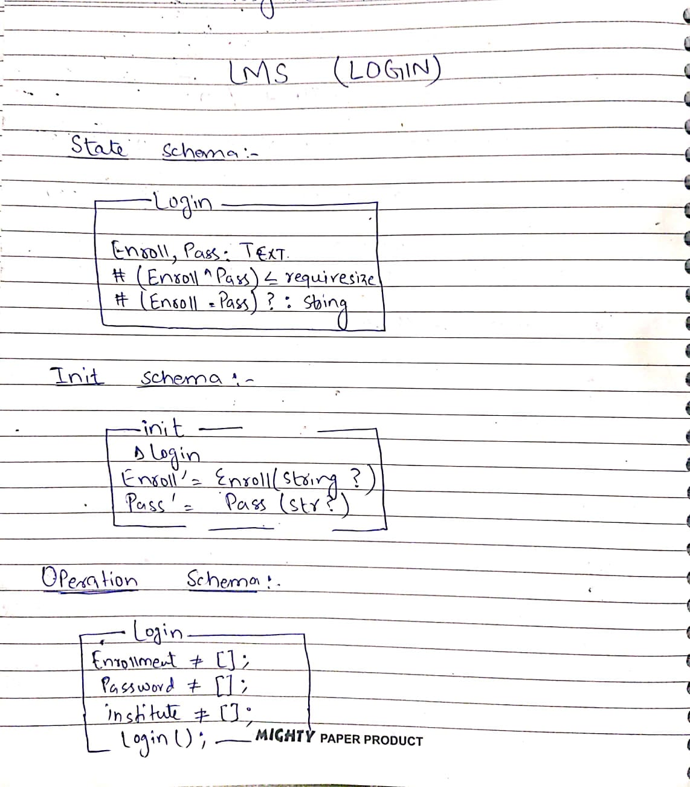

2nd Module

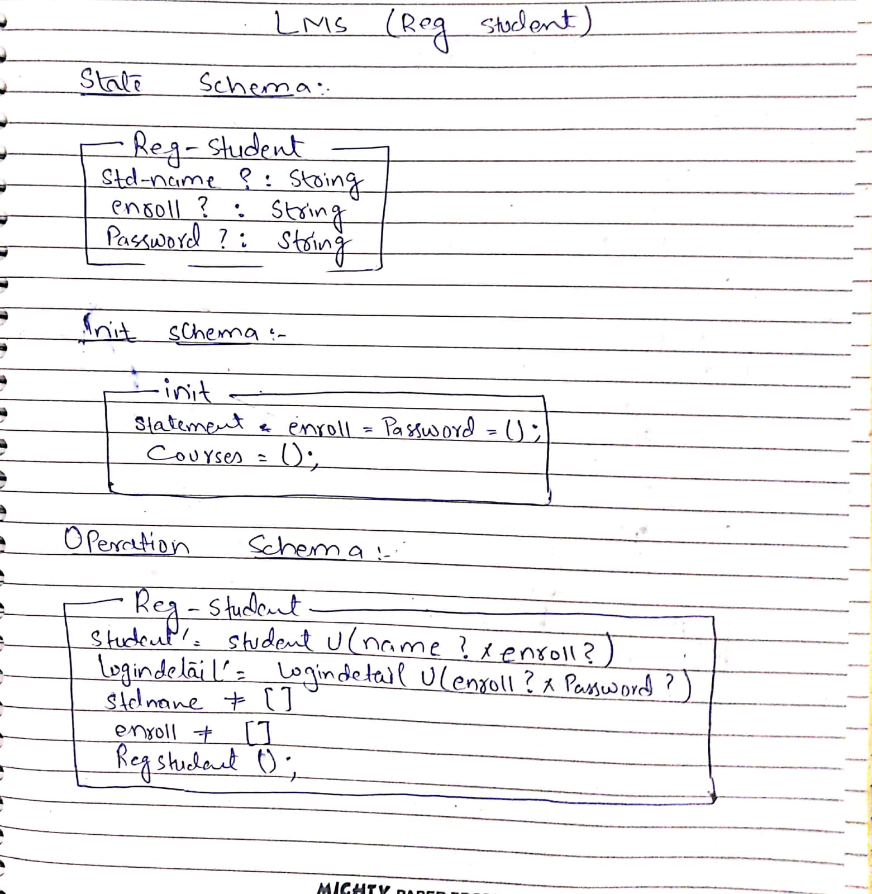

3rd Module
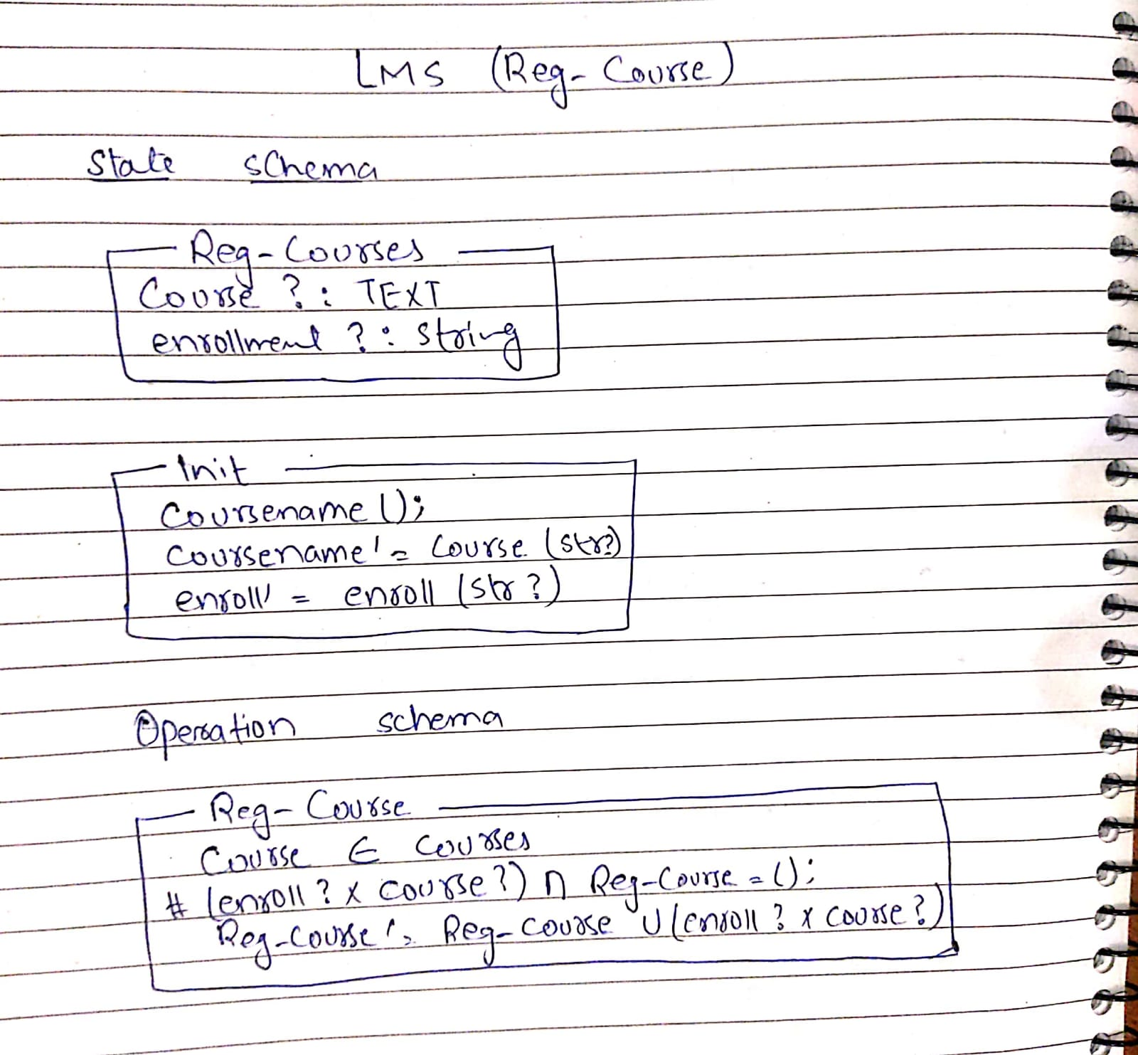

4th Module

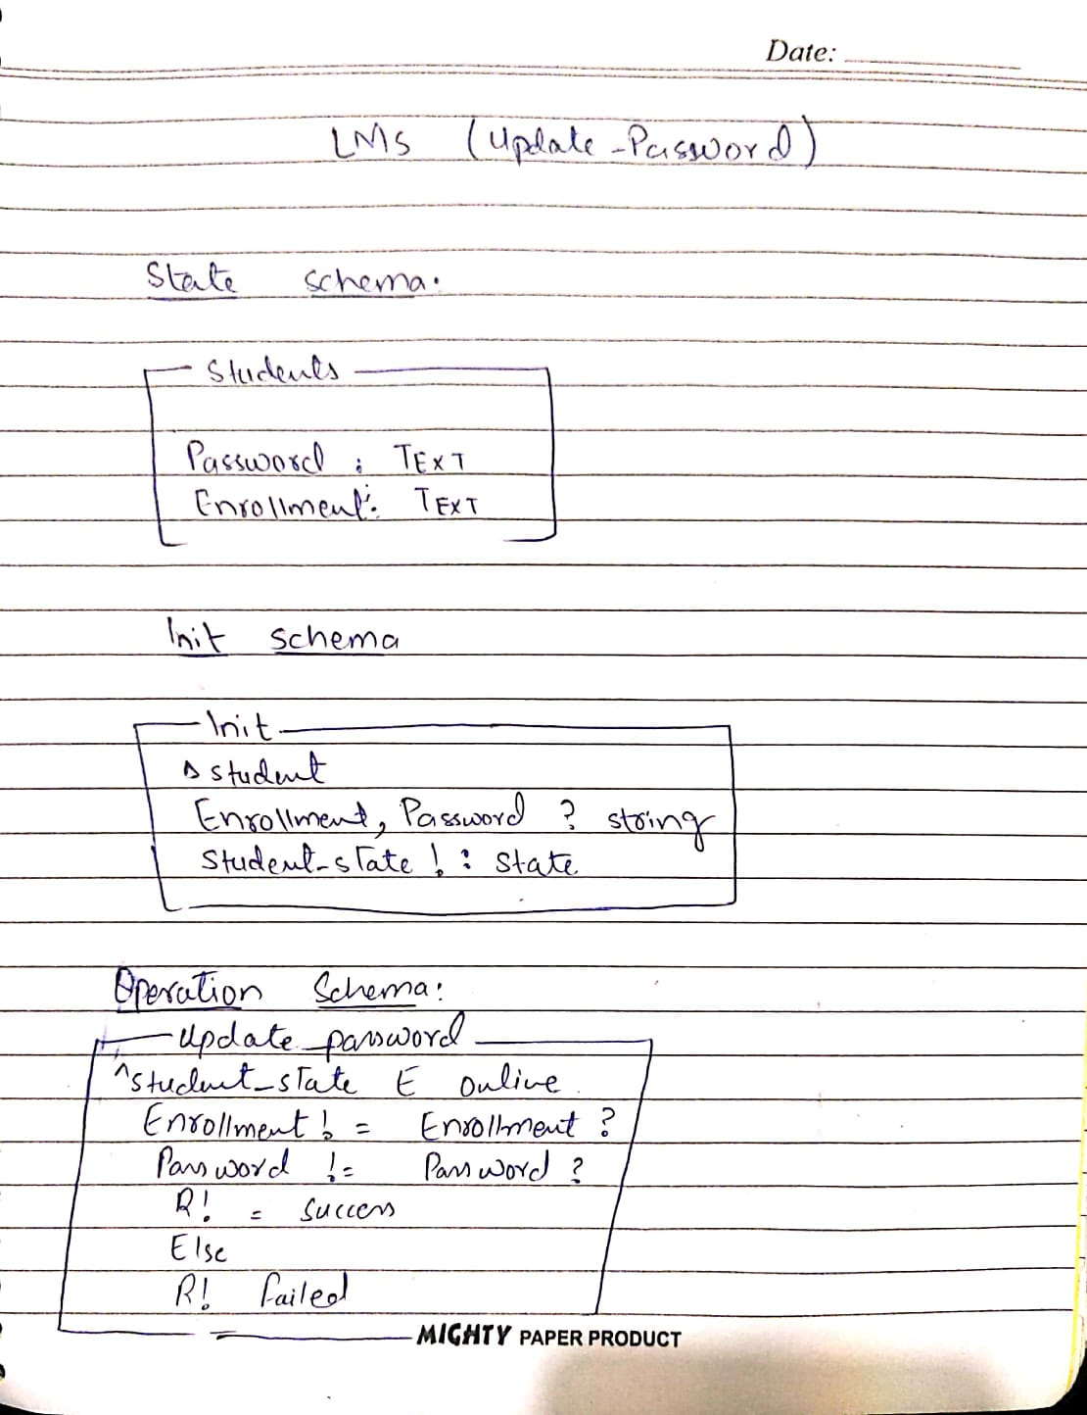

5th Module

